IdeationPhase

DefinetheProblemStatements

Date | 1November 2025
TeamID | 69c0be5ec71a9ebd6a51912e
ProjectName | StreamliningTicketAssignmentforEfficient  SupportOperations
MaximumMarks

CustomerProblemStatementTemplate:
At ABC Corporation, customers frequently experience delays in issue resolution after submitting support tickets. They often face frustration due to tickets being assigned to the wrongteams,leadingtolongerwaittimesandrepeatedfollow-ups.Customersexpectquick, accurate, and transparent support that resolves their problems efficiently. However, the current manual routing process lacks consistency and speed, resulting in dissatisfaction and reduced trust in the support system.
Customersneed a streamlined, automated ticket assignment experience that ensurestheir issues are directed to the right experts without unnecessary delays. By implementing an automated ticket routing system in ServiceNow, ABC Corporation can create a smoother, faster, and more reliable support experience that aligns with customer expectations and builds long-term satisfaction.

Section | Details
Iam | AcustomerofABCCorporationwhoreliesonpromptandaccuratetechnical support for resolving issues related to platform access, user accounts, and certifications.
I'mtryingto | Getmytechnicalissuesresolvedquicklybythecorrectsupportteam without unnecessary delays or repeated ticket transfers.
But | Myticketsareoftenassignedtothewrongteams,causinglongwaiting times, multiple follow-ups, and delayed problem resolution.
Because | Thecurrentticketassignmentprocessismanual,lacksautomation,and depends on human decision-making, leading to inefficiencies and misrouting.
Whichmakes me feel | Frustrated,undervalued,anddissatisfied asIspendtoomuchtimewaiting for help and lose confidence in the company’s support system.

Example:
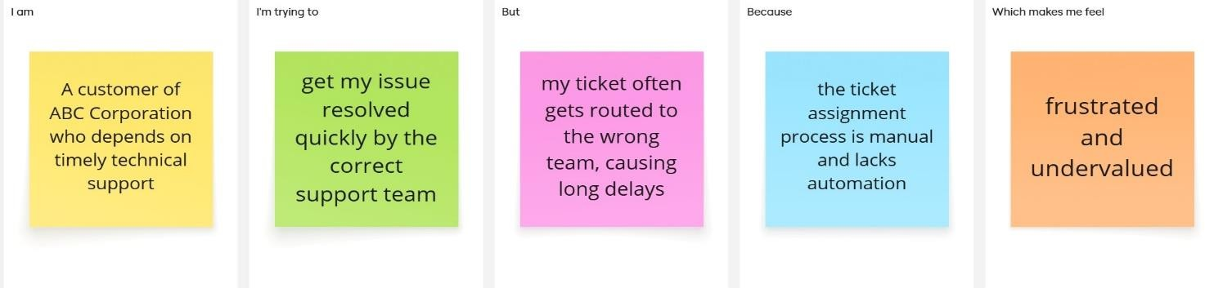

Problem  Statement(PS) | Iam  (Customer) | I’mtryingto | But | Because | Whichmakesmefeel
PS-1 | ASupport Agent | Resolve customer tickets quicklyand efficiently | Tickets areoften routedto the  wrong team | The ticket assignment process is manualand  lacks automation | Overwhelmed and delayedinresponding to customers
PS-2 | ACustomer | Get my issue resolved by the right teamwithout delay | My ticket keeps getting transferre dbetween departme  nts | Thereisno automated system to categorize and assign tickets correctly | Frustratedand undervalued

ProblemStatementPS1:
As a support agent, I’m trying to resolve customer tickets efficiently, but the current manualroutingprocessoftensendsticketstothewrongteam.Becauseofthis,Ispendextra time redirecting tickets or waiting for reassignment, which slows down response times and increases workload. This makes me feel overwhelmed and ineffective, as I’m unable to focus on solving actual customer issues. An automated system that intelligently assigns tickets to the right team would reduce confusion and help streamline the workflow.

ProblemStatementPS2:
Asacustomer,Iwant myissues toreachthecorrect supportteamquicklyso theycan be resolved without unnecessary delays. But currently, my tickets are often misrouted or taketoolongtobeaddressed. Becausethesystemlacksautomatedticketclassificationand routing, I end up waiting longer for resolutions. This makes me feel frustrated and undervalued, as it appears my concerns are not being prioritized. Implementing an automated ticket routing process in ServiceNow would ensure faster, more accurate support responses and a better customer experience.

